
Welcome to the Ladybug Class

If you would like an emailed copy of this handbook, please let us know!
Also, we encourage you to download the Kaymbu app for easier class communication.

Our classroom email is:
ladybugclass@icloud.com
Welcome Ladybug Families….

We have a fun year planned for your children and great things to learn!
Please read below to ensure that everyone has a great time at school.

- Please leave backpacks and toys at home or your car.
- One small lovey or pillow and one small blanket for nap, and please bring it in a pillowcase or cloth bag labeled with your child’s name.
- Rain boots and a coat labeled with child’s name.
- Extra change of clothes labeled with your child’s name.
- Water Bottle with child’s name
Please
Label, Label, Label everything
Reminders for you:
- All About Me’ Board: Each child will get a turn to display pictures and facts from home. You will receive an email from us when it is your child’s turn.
- Medicine: All medicine needs to be turned in to main office and if it is medicine to be administered during school hours, please check in with Dorothy. (Personal sun block, chap stick and diaper rash ointment give to a teacher.)
- Illness: Please keep children home if they might be contagious. Also, please confirm you contact info in the office. If a child vomits, has a fever, or has diarrhea 2 or more times the family is contacted to pick up the child immediately. If your child has these symptoms, they need to be symptom free for 24 hours before returning to School.
- Birthdays: Unity School celebrates “Birthday Wednesday” once a month every third Wednesday. The cook prepares a yummy home-made bread and we sing to the whole month. We can not allow any outside food to be served to children during school hours on school property, see your policy handbook for more information.

If there is anything we missed or that you still have questions about, please see Teacher Dorothy or Teacher Olivia. The Ladybugs’ Daily Schedule is attached to the back, so you know what your child is doing throughout the day, and we will email you weekly updates & photos.
Here’s to a great year!!!
Ladybug Daily Schedule

7:00 Unity Opens
8:00 Breakfast (only served 8-8:30)
8:30 Outside
9:00 Circle and Mindfulness *Water offered
9:10 Do-Activity time
10:10 Clean-up & Circle time
10:30 Snack & Review
10:45 Toileting, Hand Washing
11:00 Outside time
Can change in bad weather
11:30 Small Group *Water offered
12:00 Circle/Mindfulness’ & hand washing time
12:15 Lunch/Toileting
12:50 Rest time
2:00 Non-sleepers get quiet choices on mat
2:30 Wake up & Quiet Choice time
3:10 Circle time
3:15 Snack/Books
4:00 Outside time & Combine Classes
6:00 Unity Closes

*Wednesday -Garden time at 11:00




WE PLAY HARD EVERY DAY!



At unity school, we are learning through “hands on” activities! This often means that we get messy! We strive to make your child’s learning experience the best it can be! That means that we use Paint, glue, flubber, and some sort of messy goop every day!


Please plan ahead and send your child to school wearing “messable” play clothes – so they can dive into learning!
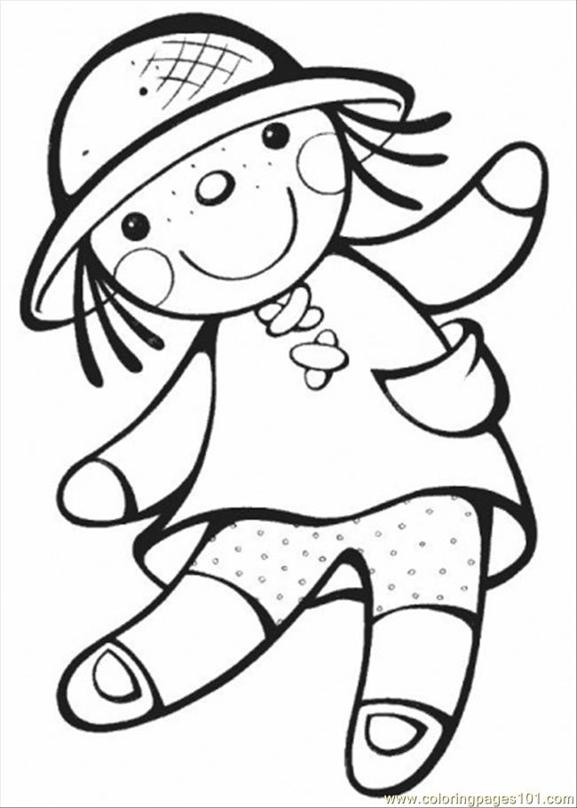




Family Photo Board



Our “Ladybug Family” board is located in our classroom. We encourage all of our Ladybug children to embrace their families and each other’s differences, by sharing pictures of each other’s families. Also, when children are sad and missing their family we can redirect them to the family board to see their family.

Family photos can include immediate family (who live together), extended family (even those that live far away), and pets.

Please email your family photos to Virginia at officemngunity@comcast.net
Or contact us at:
ladybugclass@icloud.com
Please limit them to 1 or 2 photos
Or you can wait until our “Parent Night in late September, where we’ll have a “photo Booth”

Family Culture Survey

Please answer the questions and return this form or answer via email:
ladybugs@icloud.com
Child’s full name: ______________________________________________________________________
Are there any siblings: __________
What are their names? ______________________________________________________________________________
Do you have any pets? If so, what kinds and what are their names? ______________________________________________________________________________
Has the family always lived in Oregon? __________
If not, what states or countries have you lived in? Or what other languages do you or your child know?
______________________________________________________________________________
What are your families’ favorite holidays or celebrations? Or is there anything you prefer not to celebrate? ______________________________________________________________________________
What are your families’ favorite foods? ____________________________________________________________________________________________________________________________________________________________
Is there a recipe, craft or tradition you would like to share with the class? __________________________________________________________________________________________________________________________________________________________________________________________________________________________________________
Are there any cultural or ethnical accommodations we can help with?
Thank you! The Ladybug Team

