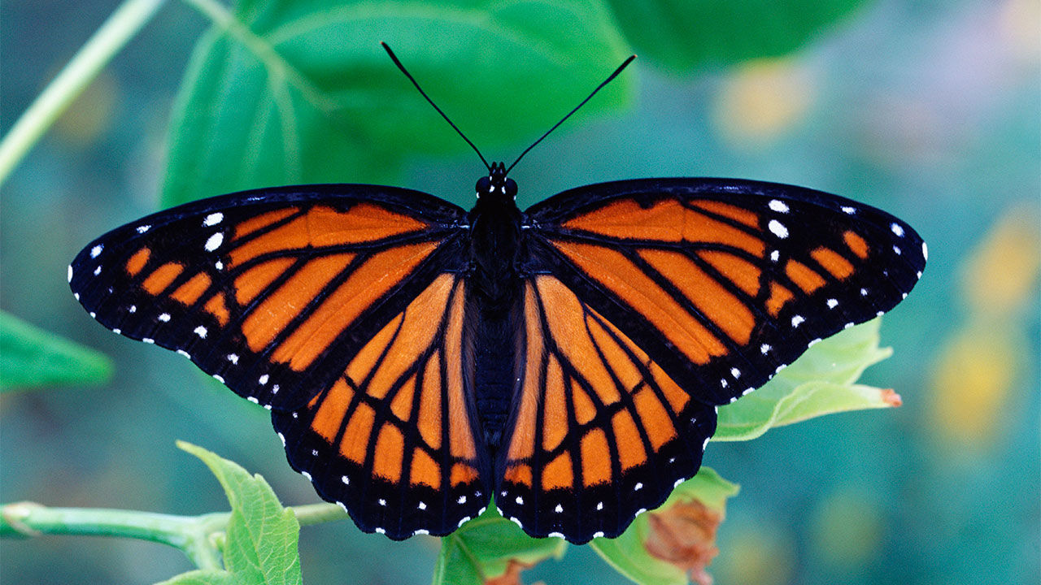Butterfly
Family
Handbook
2025-2026

September 2025 — August 2026
Welcome to the Butterfly room! We are so glad you are here with us! What an exciting upcoming year we have planned for your children. The Butterfly teaching team has created an environment where your children will not only have fun and feel safe, but also be able to explore, learn, create and become a wonderful “community” among their teachers and peers in ways that are age and developmentally appropriate.

It is our goal to nurture and guide your children in ways that will encourage their natural sense of wonder so that they can grow and learn at “their” pace, while being challenged with new and exciting materials and real-life experiences.

Again, we would like to welcome you to this new chapter in your child’s life…what a fun one it will be!

Below, you will find some important and useful information that we feel will make “your” life as a Butterfly grown-up easier and hopefully more convenient.

What to Bring
- Although your children are getting bigger and older, accidents still happen on occasion. Please be sure to have a full set of weather appropriate, spare clothes in your child’s cubby, marked with his/her full name. We have attached a 1-gallon sized bag to put them in. We have very limited space in our room so please only bring what will fit in their bag (no backpacks please). If your child uses his/her spare clothes, please be sure to replace them right away as we have a very small collection of Unity clothes available.
- Rest time in Butterfly-land is quite a bit shorter than what you may be used to, however we do ask that you still bring a “small” blanket and a “small” pillow/stuffy to make rest time more comfortable. We have supplied you with a Pillowcase that your child’s rest items must be able to fit in. As we mentioned before, we have very limited space, so everything that comes to school must be able to fit in the bag provided, so that we can fit them in cubbies and bins. Also, take items home on Fridays (or last day of the week for your child) and wash them for the next week.
- Because of limited space, we ask that no backpacks be brought to school. Our cubby area/hooks are very small, and each child will be assigned one small basket (cubby) and one hook below their cubby. Their names are clearly marked on both. When the weather gets colder and wetter, we will need all that space to accommodate for coats and sweaters.
- When the rainy season is upon us, please be sure to have a pair of rain friendly shoes/boot and a raincoat here at school, as we go outside in all types of weather. We want all of our Butterflies to be warm, dry and comfy. We also encourage sweaters or light jackets to wear beneath the rain gear.
- Water bottle labeled with child’s name on it. Take home on Fridays (or last day of the week) and wash them for the next week.

What NOT to bring
- Food or drinks of any kind. We provide a healthy breakfast, 2 snacks and lunch every day. If your child has any food related allergies, please let the office and your teachers know so that we can accommodate your child needs.
- Toys from home, other than “stuffed animals” for rest time. If your child brings a toy, we will ask you to take it home with you when you leave.
- Weapon or superhero themed items of any kind.

Messy, messy, messy
- Unity is a school of “Developmentally Appropriate Practice”. It is not “DAP” to ask young children to “stay clean” while at preschool. Please, please, please, dress you children in play clothes (things you aren’t too concerned with getting messy). Children are natural “explorers”, and sometimes that means that they are going to explore messy things. What a wonderful thing it would be if all of us adults could embrace this and know that it is a VERY important part of a child’s developmental learning process. This is a “stressor” that we feel children should not have to endure. If you have any questions or concerns regarding this issue, please feel free to chat with the Butterfly teachers. We really appreciate your support!

Art Files
- Your children will be very busy throughout their days here, so please be sure to check their art files daily. The files are located in the art area. It’s a bin sitting on a small table. They are organized by your children’s “first” names.

Parent Board
- Our Parent Information Board is located right as you walk into our room, on your left. On it you will find our WEB, the Weekly Schedule, Small Group Activities and all other important info. If there is an especially important piece of information you need to know, we will display it on the left-hand side of our door, outside our room with a big, bright arrow pointing to it!
- Bring picture from home that we can make a family board to represent your family & culture in class.

Super Special
- We love, love, love having Parent Helpers in our room! We are hoping to incorporate some Cultural experiences/Traditions that parents can bring to our class to share with the children. If you have something you would like to share, that reflects your family’s culture/traditions/history, such as music, cooking, stories, etc. Please let us know so we can arrange a time for you to come in!
- To go along with having parents sharing their family’s cultures, we have a “family tree” in which each family (if you choose to participate) will be celebrated! We plan on having this begin in October, so please keep an eye out for more information!

Field Trips
- We will be going on several field trips this year. Most of them will be too far to walk, so we will be taking the Unity “purple” bus. Because the bus is used primarily for drop-offs and pick-ups from public schools, we will be planning our trips around their schedules. We love having parent chaperones, so please feel free to sign up when you see that we are going somewhere fun! All field trips will be announced with a note in your mailbox, a note on the field trip board in the front lobby AND on the wall right outside our room by the door.

Last but not least
- Because this is a Pre-kindergarten class, we are going to be working very hard this year to prepare your children for their next big step, Kindergarten”! We ask that you have your children to school no later than 9:00 am. This will ensure that they are getting the entire enrichment program. We do understand that there will be times when this is not possible, so please don’t stress over it.

Well, that’s about it…pretty much everything is covered here, however if we missed something please feel free to ask any of the Butterfly teachers and we will do our best to answer your questions. If we can’t right away, we will certainly find out the answer and get back to you ASAP!

We are all so very excited about spending this year with your children. What a super fun and wonder-filled year we will have together! Oh and… be prepared to be “amazed” by what your children learn!

With Much Love and Many Hugs,
Butterfly Team

