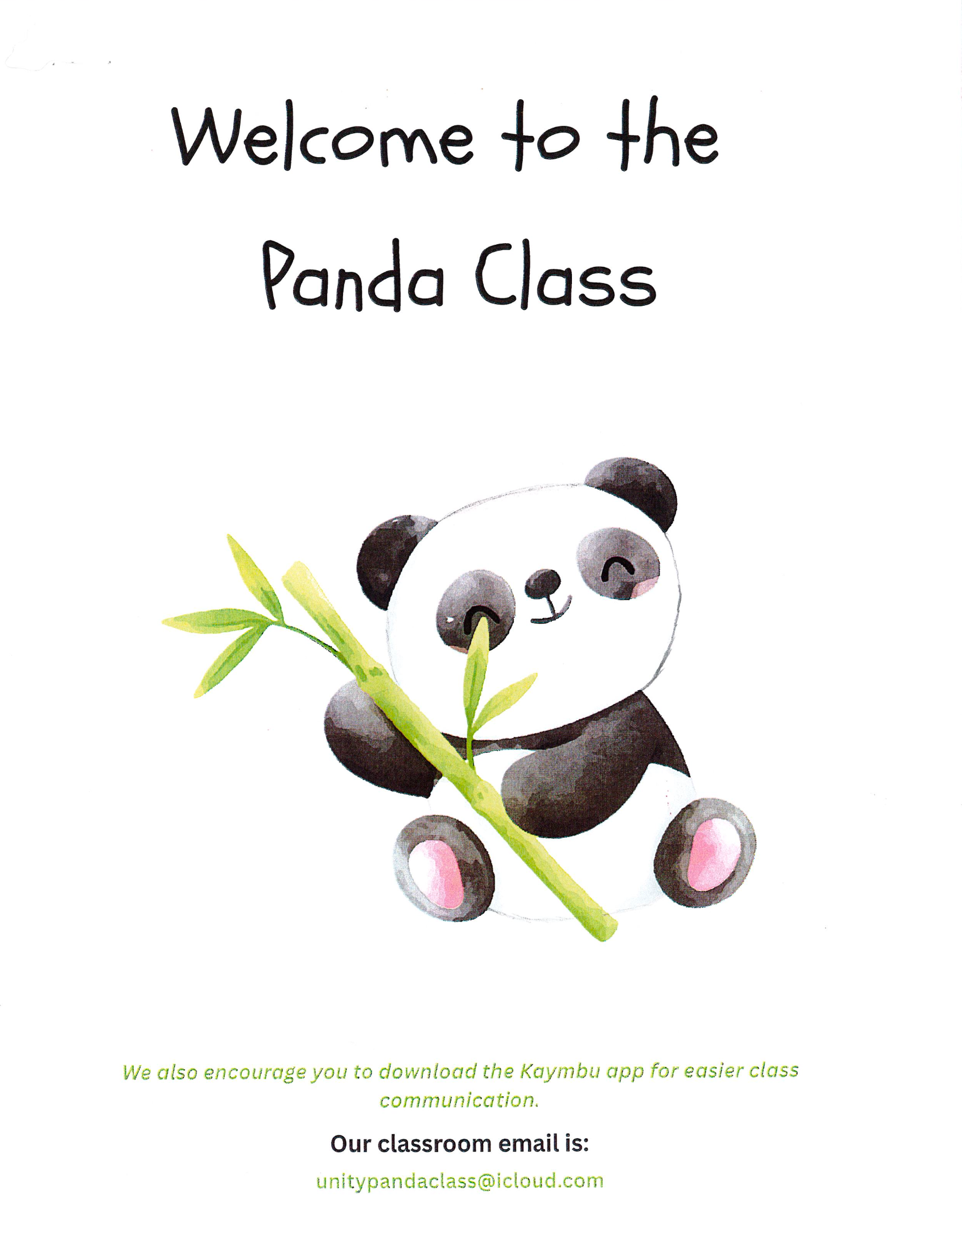

We have fun year planned for your children and many new things to Learn.
Please check the list to ensure that your child has everything they need for fun and learning at school

- Per Unity’s policy - leave toys and Binky’s at home or in your car
- One lovey and blanket (and a small pillow if desired)
- Water bottle
- One or two changes of weather appropriate clothing
- Rain boots and raincoat
- Warm coat
- A reusable wet bag for sending home soiled clothes (not required, but helpful)
PLEASE-PLEASE-PLEASE
LABEL ALL PERSONAL ITEMS WITH YOUR CHILD’S NAME!
Seriously…Please label your child’s things
